**Lecture (3a) Nonlinear Algebraic Equations: Fixed point iteration method**

1. **Definition of the fixed point**

**If  🡪 We say that  is a fixed point of **

1. **Fixed point iteration techniques**

** with the prescribed initial estimate**

1. **Solution process of the fixed point iteration techniques**

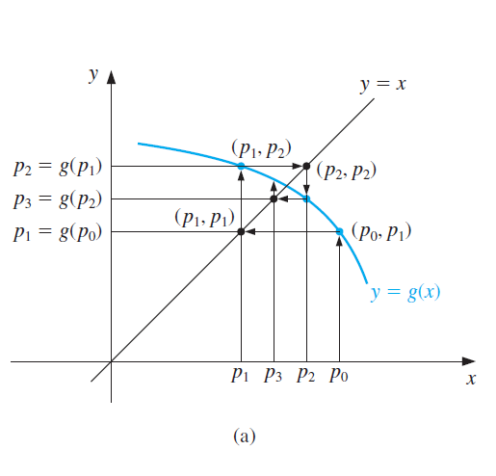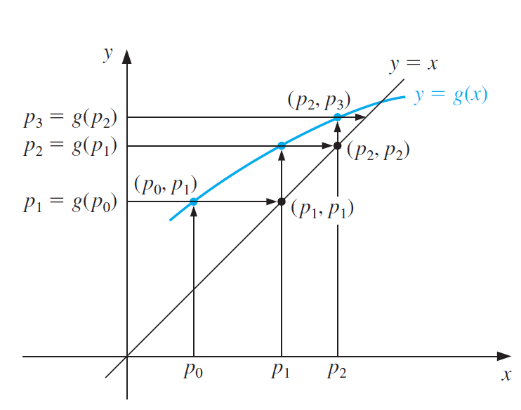

1. **Example Application to the nonlinear algebraic equation**

**(4-1) Example Application to the nonlinear algebraic equation**



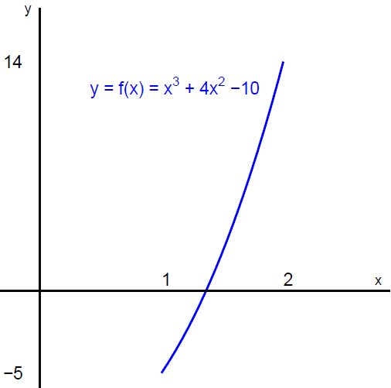**Possible choice of the fixed-point form point **



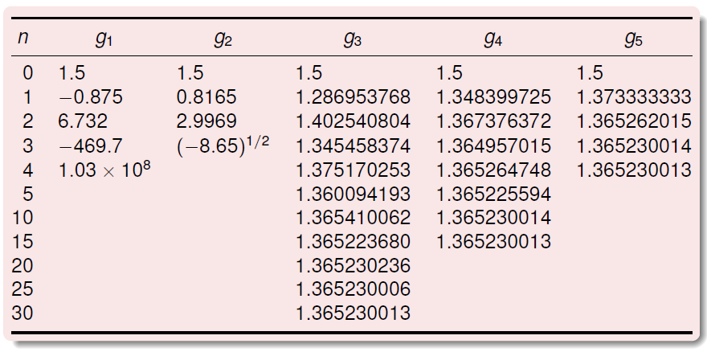

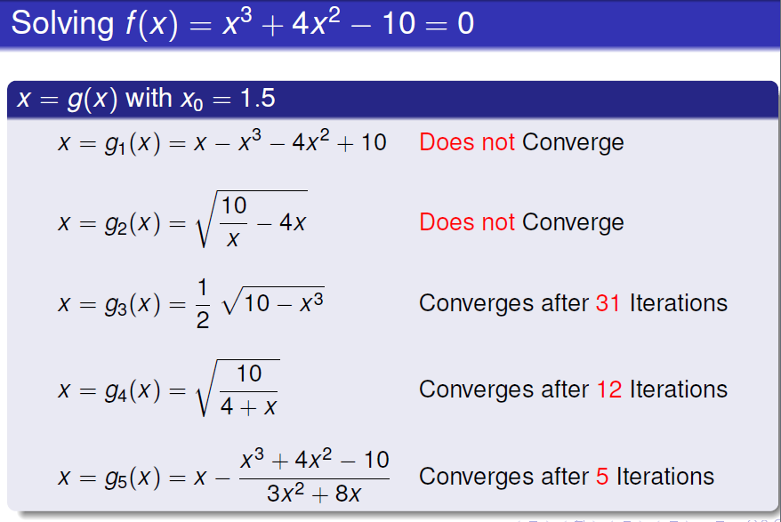

**(4-2) Example Application to the nonlinear algebraic equation**



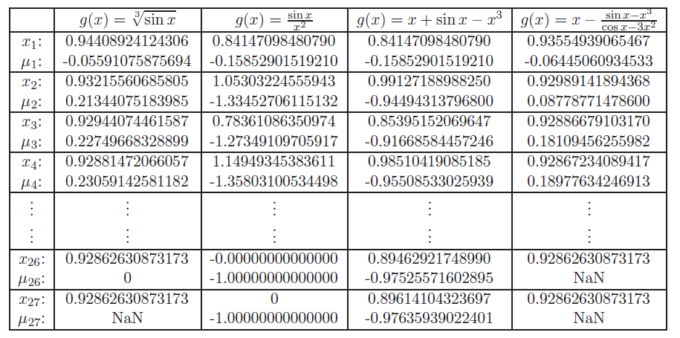

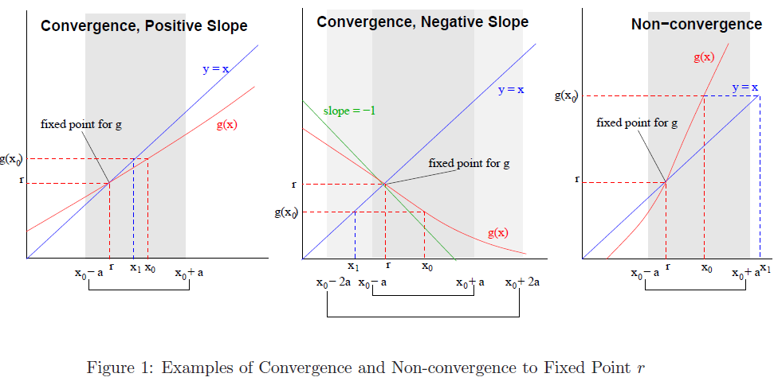

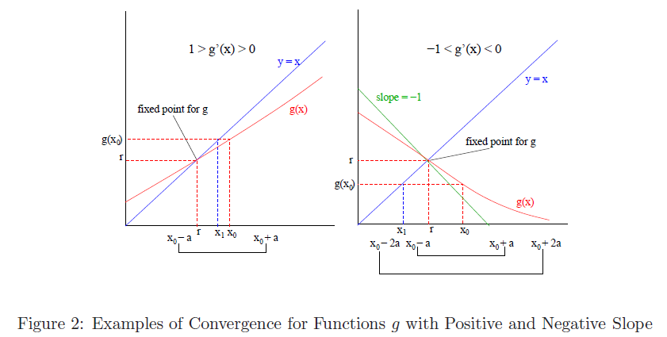

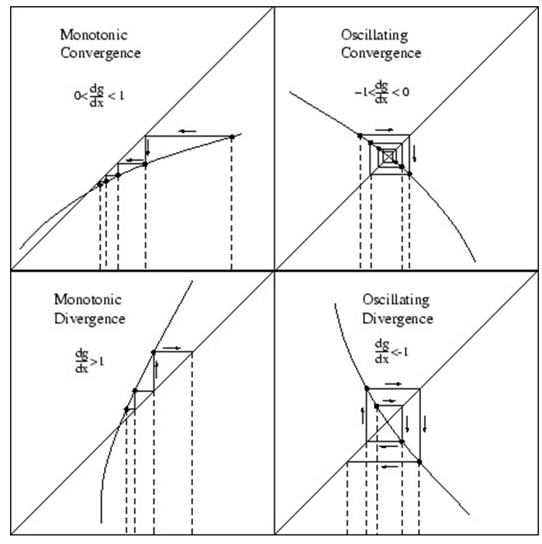

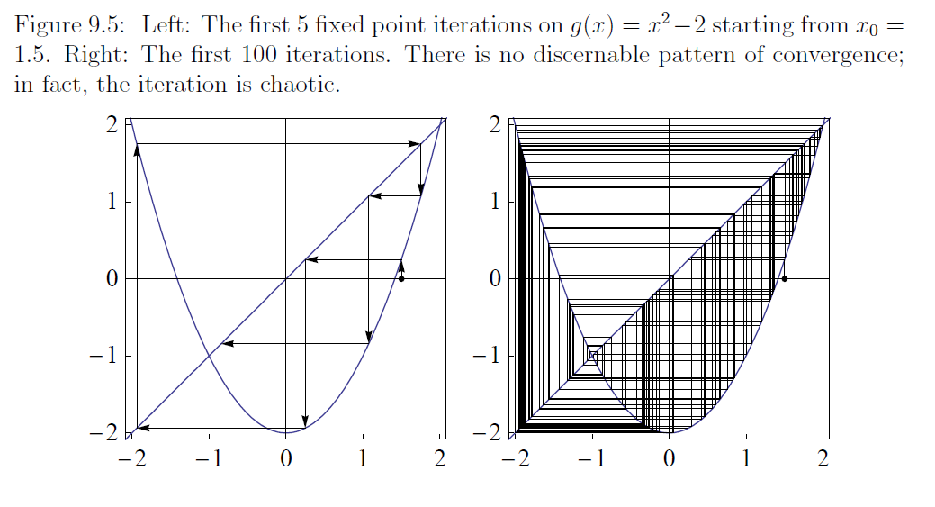

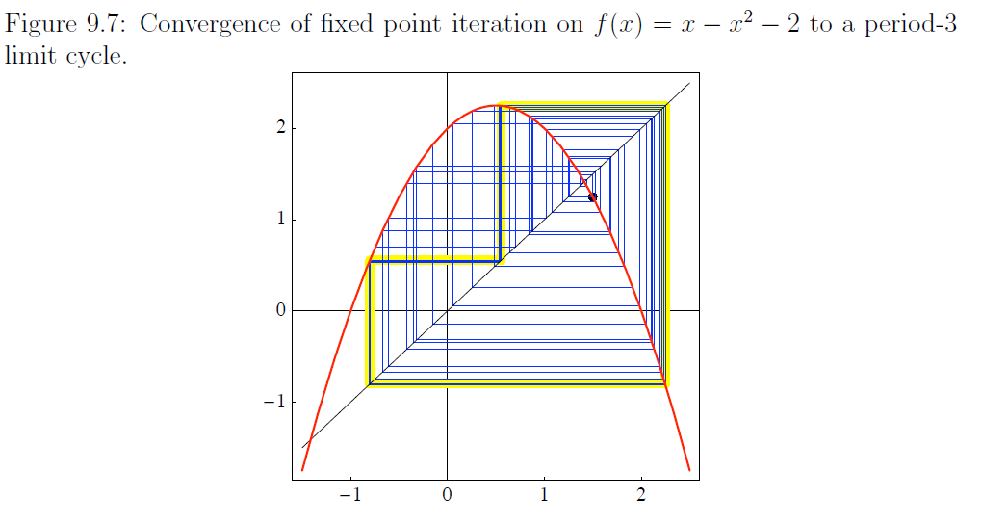

1. **Various algorithms**

**Problem statement**

**Find  which satisfies  with **

**(5-1) Mann’s iteration method (MAN)**



**(5-2) Ishikawa iteration methods**

** which is reduced to MAN with **

**(5-3) Noor iteration methods**



**(5-4) SP iteration methods**



**(5-5) S iteration methods**



**(5-6) CR iteration methods**



**(Ref:** A PICARD-S HYBRID TYPE ITERATION METHOD FOR SOLVING A DIFFERENTIAL EQUATION WITH RETARDED ARGUMENT)

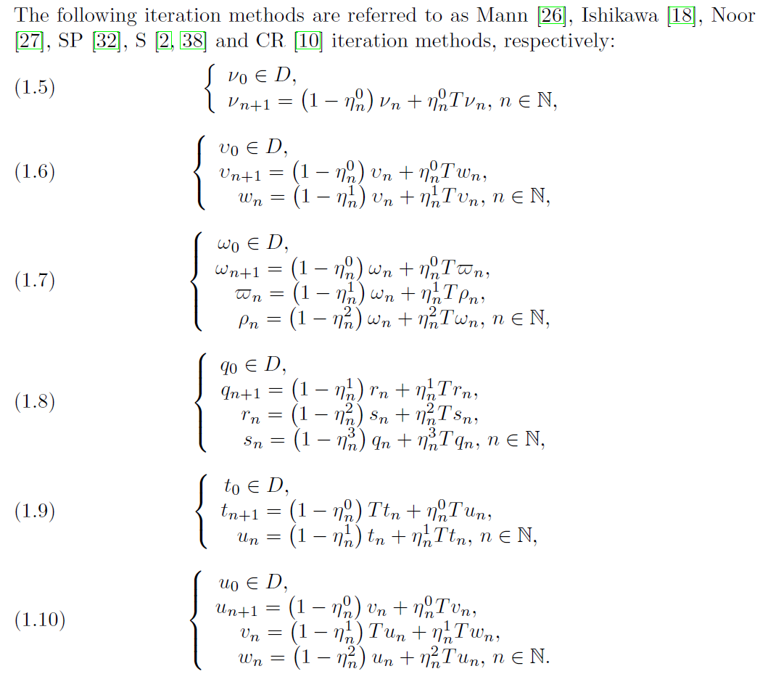

To answer this problem, we introduce the following iteration method called Picard-S iteration:

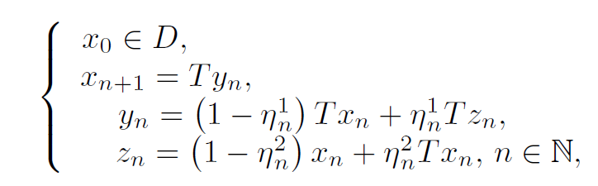

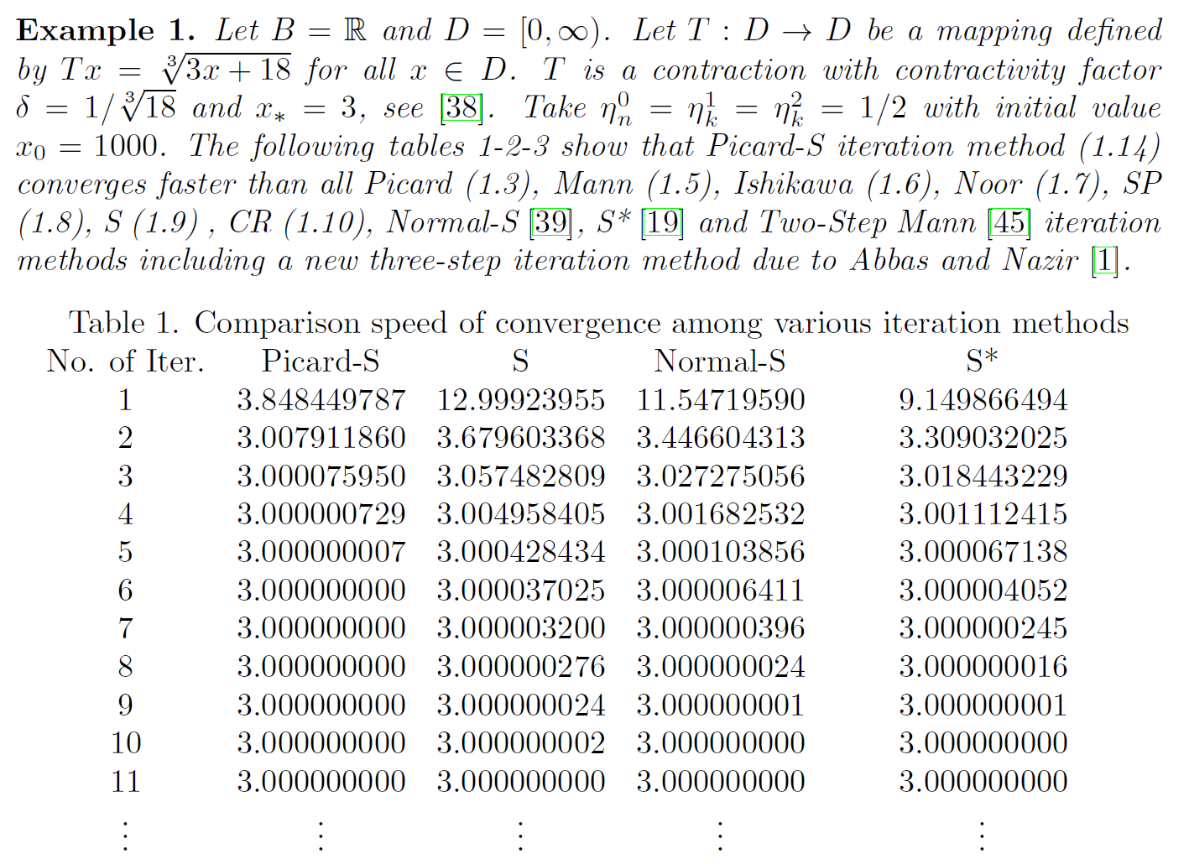

ON THE RATE OF CONVERGENCE AND DATA DEPENDENCE OF JUNGCK MULTISTEP ITERATIVE SCHEMES

**Example: **

**Solution coditions **

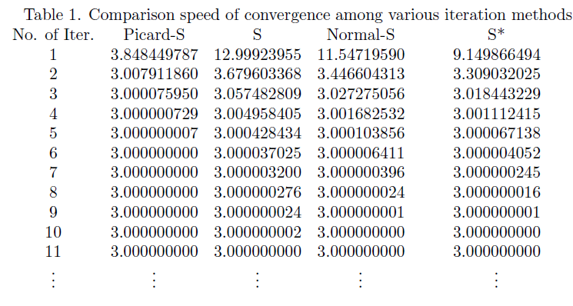

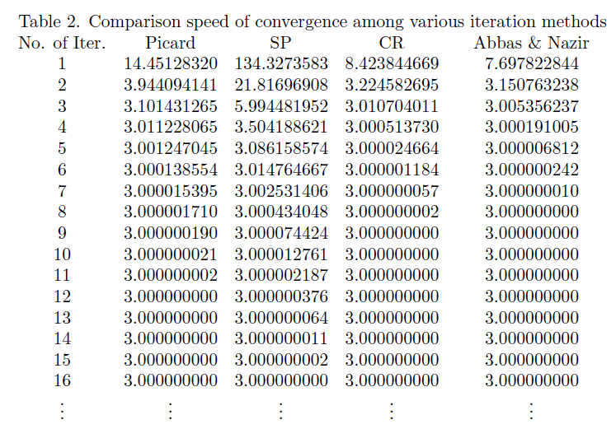

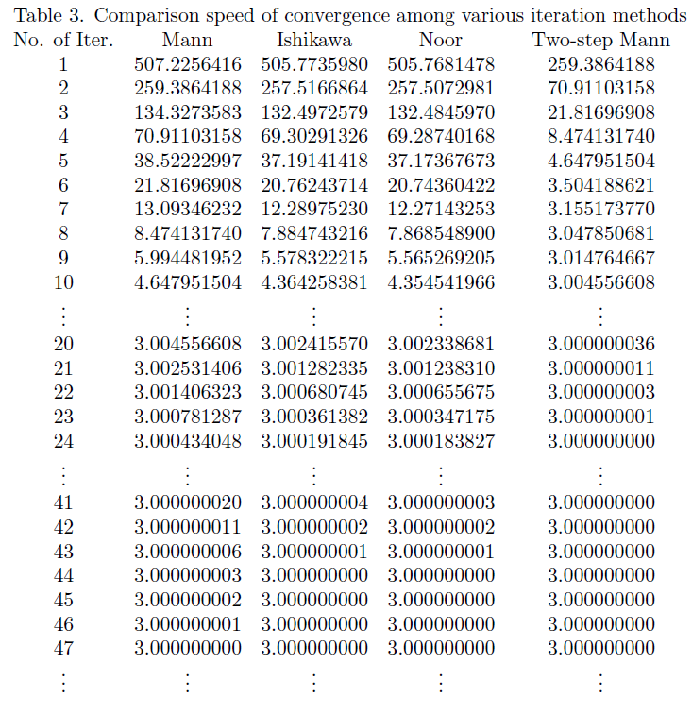

**Appendix : Example of the fixed point iteration method**

**(1) Nonlinear algebraic equation: Newton-Raphson Method**

* Definition of the system of nonlinear algebraic equations(NAEs)



, which has n unknowns and n nonlinear equations

* 1st Order approximation of function value around x



* Newton-Raphson Method for the system of Nonlinear Equations

The Newton-Raphson Method approximate the root with the vector satisfying



🡪 

,Which is a form of the fixed point iteration method 

(Example) Newton-Raphson Method for the system of Nonlinear Equations

  

🡪 



**(2) Linear algebraic equation: Gauss-Seidal Method**

 **🡪** **🡪** 

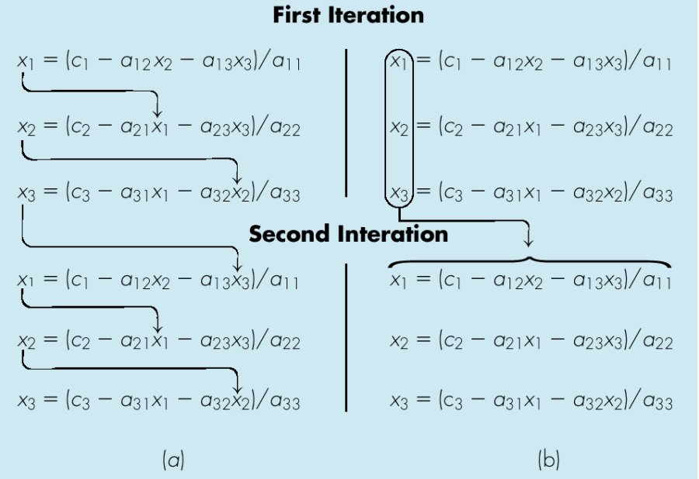

(a) Gauss-Seidel Method (b) Jacobi Method

Jacobi method

 where 

🡪 

,which is the form of the fixed point iteration method 

**(3) Laplace equation and Poisson equation**

(3-1) Model Poisson equation

**Poisson problem**



(3-2) FDM (Finite difference method) using the central differencing algorithm

**Computational nodes**

**(i+1,j)**

**(i,j)**

**(i,j+1)**

**(i,j-1)**

**(i-1,j)**

*h*

*h*

**Computational stencil**

**(i+1,j)**

**(i,j)**

**(i,j+1)**

**(i,j-1)**

**(i-1,j)**







**Finite difference approximation using the central difference formula**







(3-3) ADI method



Let’s define



**H**: Horizontal matrix

**V**: Vertical matrix

**D**: Diagonal with negative elements

: Column vector containing for all 

: Column vector containing for all in the same sequence of the elements of 

Then





It can be transformed using an arbitrary real number *r* into

 

**ADI method with a horizontal sweep followed by a vertical sweep** can be formulated as



Where are to be determined so that the spectral radius (the maximum absolute value of eigenvalues of the system matrix) becomes as small as possible to enhance the convergence.

(3-4) Gauss-Seidal method: Fixed point iteration method



,which is the form of the fixed point iteration method 

(3-5) Comparison with Iterative Methods for a model problem

**Example problem**



Which has the exact solution:



For the computational domain of



The unknown *u* and its exact solution at each node can be written as





**(4) Implicit ODE Solver**

(4-1) Initial value problem (IVP) with the *p*th-order system dynamics is considered.

 (1)

Integration form

 (2)

Using affine transformation

 (3)

 (4)

(4-2) Computational nodes and function interpolation using the Lagrange polynomials

Computational nodes:  , 

Lagrange interpolation of the forcing function



Eq (4) for each node becomes

 (5)

Where  is a component of the integration matrix.

The solution of the ODE can be obtained by solving the following nonlinear algebraic equations



,which can be solved by using the Newton-like method or the fixed point iteration techniques

(4-3) Integration matrix

--------------------------------------------------------------------------------------------

Gauss-Lobatto Integration Matrix : Pseudospectral Method

--------------------------------------------------------------------------------------------

Number of nodes = 2

--------------------------------------------------------------------------------------------

j Tau(j) I(j,1) I(j,2)

--------------------------------------------------------------------------------------------

1 -.10000000E+01 0.00000000E+00 0.00000000E+00

2 0.10000000E+01 0.10000000E+01 0.10000000E+01

--------------------------------------------------------------------------------------------

Number of nodes = 3

--------------------------------------------------------------------------------------------

j Tau(j) I(j,1) I(j,2) I(j,3)

--------------------------------------------------------------------------------------------

1 -.10000000E+01 0.00000000E+00 0.00000000E+00 0.00000000E+00

2 0.00000000E+00 0.41666667E+00 0.66666667E+00 -.83333333E-01

3 0.10000000E+01 0.33333333E+00 0.13333333E+01 0.33333333E+00

--------------------------------------------------------------------------------------------

Number of nodes = 4

--------------------------------------------------------------------------------------------

j Tau(j) I(j,1) I(j,2) I(j,3) I(j,4)

--------------------------------------------------------------------------------------------

1 -.10000000E+01 0.00000000E+00 0.00000000E+00 0.00000000E+00 0.00000000E+00

2 -.44721360E+00 0.22060113E+00 0.37939887E+00 -.67814728E-01 0.20601133E-01

3 0.44721360E+00 0.14606553E+00 0.90114806E+00 0.45393447E+00 -.53934466E-01

4 0.10000000E+01 0.16666667E+00 0.83333333E+00 0.83333333E+00 0.16666667E+00

--------------------------------------------------------------------------------------------

Number of nodes = 5

--------------------------------------------------------------------------------------------

j Tau(j) I(j,1) I(j,2) I(j,3) I(j,4) I(j,5)

--------------------------------------------------------------------------------------------

1 -.10000000E+01 0.00000000E+00 0.00000000E+00 0.00000000E+00 0.00000000E+00 0.00000000E+00

2 -.65465367E+00 0.13545686E+00 0.23948954E+00 -.43471444E-01 0.21271648E-01 -.74002785E-02

3 0.00000000E+00 0.81250000E-01 0.60636837E+00 0.35555556E+00 -.61923922E-01 0.18750000E-01

4 0.65465367E+00 0.10740028E+00 0.52317280E+00 0.75458255E+00 0.30495491E+00 -.35456864E-01

5 0.10000000E+01 0.10000000E+00 0.54444444E+00 0.71111111E+00 0.54444444E+00 0.10000000E+00

--------------------------------------------------------------------------------------------

Number of nodes = 6

--------------------------------------------------------------------------------------------

j Tau(j) I(j,1) I(j,2) I(j,3) I(j,4) I(j,5) I(j,6)

--------------------------------------------------------------------------------------------

1 -.10000000E+01 0.00000000E+00 0.00000000E+00 0.00000000E+00 0.00000000E+00 0.00000000E+00 0.00000000E+00

2 -.76505532E+00 0.91359610E-01 0.16373563E+00 -.29749212E-01 0.15255352E-01 -.89435609E-02 0.32868520E-02

3 -.28523152E+00 0.51816771E-01 0.42768162E+00 0.26792147E+00 -.48008149E-01 0.23615393E-01 -.82586191E-02

4 0.28523152E+00 0.74925286E-01 0.35485956E+00 0.60286653E+00 0.28693691E+00 -.49206661E-01 0.14849896E-01

5 0.76505532E+00 0.63379815E-01 0.38741852E+00 0.53960302E+00 0.58460759E+00 0.21473932E+00 -.24692944E-01

6 0.10000000E+01 0.66666667E-01 0.37847496E+00 0.55485838E+00 0.55485838E+00 0.37847496E+00 0.66666667E-01

--------------------------------------------------------------------------------------------

Number of nodes = 7

--------------------------------------------------------------------------------------------

j Tau(j) I(j,1) I(j,2) I(j,3) I(j,4) I(j,5) I(j,6) I(j,7)

--------------------------------------------------------------------------------------------

1 -.10000000E+01 0.00000000E+00 0.00000000E+00 0.00000000E+00 0.00000000E+00 0.00000000E+00 0.00000000E+00 0.00000000E+00

2 -.83022390E+00 0.65692529E-01 0.11864579E+00 -.21537189E-01 0.11195184E-01 -.69778599E-02 0.44341932E-02 -.16765409E-02

3 -.46884879E+00 0.36004446E-01 0.31540226E+00 0.20470962E+00 -.36956519E-01 0.19155160E-01 -.11363729E-01 0.41999622E-02

4 0.00000000E+00 0.55059524E-01 0.25557651E+00 0.47497131E+00 0.24380952E+00 -.43225924E-01 0.21249536E-01 -.74404762E-02

5 0.46884879E+00 0.43419085E-01 0.28818978E+00 0.41259022E+00 0.52457557E+00 0.22703576E+00 -.38576214E-01 0.11614601E-01

6 0.83022390E+00 0.49295589E-01 0.27239185E+00 0.43872324E+00 0.47642386E+00 0.45328257E+00 0.15818026E+00 -.18073481E-01

7 0.10000000E+01 0.47619048E-01 0.27682605E+00 0.43174538E+00 0.48761905E+00 0.43174538E+00 0.27682605E+00 0.47619048E-01

--------------------------------------------------------------------------------------------

Number of nodes = 8

--------------------------------------------------------------------------------------------

j Tau(j) I(j,1) I(j,2) I(j,3) I(j,4) I(j,5) I(j,6) I(j,7) I(j,8)

--------------------------------------------------------------------------------------------

1 -.10000000E+01 0.00000000E+00 0.00000000E+00 0.00000000E+00 0.00000000E+00 0.00000000E+00 0.00000000E+00 0.00000000E+00 0.00000000E+00

2 -.87174015E+00 0.49475029E-01 0.89785325E-01 -.16281535E-01 0.85081651E-02 -.54084102E-02 0.36907734E-02 -.24524420E-02 0.94294653E-03

3 -.59170018E+00 0.26517440E-01 0.24129947E+00 0.15999527E+00 -.28961662E-01 0.15263898E-01 -.96653378E-02 0.62099000E-02 -.23591570E-02

4 -.20929922E+00 0.42068713E-01 0.19256036E+00 0.37808330E+00 0.20249191E+00 -.36274640E-01 0.18834020E-01 -.11217723E-01 0.41548451E-02

5 0.20929922E+00 0.31559441E-01 0.22192195E+00 0.32228867E+00 0.44873344E+00 0.20996688E+00 -.36960607E-01 0.18143871E-01 -.63544277E-02

6 0.59170018E+00 0.38073443E-01 0.20449433E+00 0.35078803E+00 0.39719490E+00 0.44142046E+00 0.18112742E+00 -.30595239E-01 0.91968461E-02

7 0.87174015E+00 0.34771339E-01 0.21315667E+00 0.33743192E+00 0.41786720E+00 0.40395063E+00 0.35740423E+00 0.12091890E+00 -.13760743E-01

8 0.10000000E+01 0.35714286E-01 0.21070423E+00 0.34112269E+00 0.41245879E+00 0.41245879E+00 0.34112269E+00 0.21070423E+00 0.35714286E-01

--------------------------------------------------------------------------------------------

Number of nodes = 9

--------------------------------------------------------------------------------------------

j Tau(j) I(j,1) I(j,2) I(j,3) I(j,4) I(j,5) I(j,6) I(j,7) I(j,8) I(j,9)

--------------------------------------------------------------------------------------------

1 -.10000000E+01 0.00000000E+00 0.00000000E+00 0.00000000E+00 0.00000000E+00 0.00000000E+00 0.00000000E+00 0.00000000E+00 0.00000000E+00 0.00000000E+00

2 -.89975800E+00 0.38587676E-01 0.70251042E-01 -.12728205E-01 0.66675544E-02 -.42736940E-02 0.29885983E-02 -.21481214E-02 0.14675453E-02 -.57039155E-03

3 -.67718628E+00 0.20368161E-01 0.19017302E+00 0.12786399E+00 -.23171463E-01 0.12299874E-01 -.79616516E-02 0.55106482E-02 -.36950103E-02 0.14261541E-02

4 -.36311746E+00 0.33138740E-01 0.15018703E+00 0.30576412E+00 0.16817096E+00 -.30261346E-01 0.16001207E-01 -.10192652E-01 0.65792491E-02 -.25047753E-02

5 0.00000000E+00 0.23980035E-01 0.17573967E+00 0.25736444E+00 0.37951616E+00 0.18575964E+00 -.33087650E-01 0.17174268E-01 -.10244306E-01 0.37977431E-02

6 0.36311746E+00 0.30282553E-01 0.15891611E+00 0.28473136E+00 0.33042730E+00 0.40178062E+00 0.17825755E+00 -.31225410E-01 0.15308327E-01 -.53609619E-02

7 0.67718628E+00 0.26351624E-01 0.16919037E+00 0.26902806E+00 0.35439016E+00 0.35921940E+00 0.36959997E+00 0.14667472E+00 -.24677655E-01 0.74096170E-02

8 0.89975800E+00 0.28348169E-01 0.16402782E+00 0.27668683E+00 0.34343991E+00 0.37579297E+00 0.33976096E+00 0.28726692E+00 0.95244320E-01 -.10809899E-01

9 0.10000000E+01 0.27777778E-01 0.16549536E+00 0.27453871E+00 0.34642851E+00 0.37151927E+00 0.34642851E+00 0.27453871E+00 0.16549536E+00 0.27777778E-01

--------------------------------------------------------------------------------------------

Number of nodes = 10

--------------------------------------------------------------------------------------------

j Tau(j) I(j,1) I(j,2) I(j,3) I(j,4) I(j,5) I(j,6) I(j,7) I(j,8) I(j,9) I(j,10)

--------------------------------------------------------------------------------------------

1 -.10000000E+01 0.00000000E+00 0.00000000E+00 0.00000000E+00 0.00000000E+00 0.00000000E+00 0.00000000E+00 0.00000000E+00 0.00000000E+00 0.00000000E+00 0.00000000E+00

2 -.91953391E+00 0.30930298E-01 0.56435952E-01 -.10218152E-01 0.53594052E-02 -.34492466E-02 0.24383800E-02 -.18028208E-02 0.13395205E-02 -.93228345E-03 0.36503904E-03

3 -.73877387E+00 0.16149130E-01 0.15354903E+00 0.10423607E+00 -.18899411E-01 0.10068462E-01 -.65809174E-02 0.46767081E-02 -.34008831E-02 0.23403410E-02 -.91239610E-03

4 -.47792495E+00 0.26752037E-01 0.12036908E+00 0.25130615E+00 0.14071106E+00 -.25378273E-01 0.13529395E-01 -.88212331E-02 0.61446888E-02 -.41380198E-02 0.16001511E-02

5 -.16527896E+00 0.18849744E-01 0.14239943E+00 0.20965286E+00 0.32141894E+00 0.16193345E+00 -.29001289E-01 0.15343358E-01 -.97985363E-02 0.63388872E-02 -.24157978E-02

6 0.16527896E+00 0.24638020E-01 0.12696710E+00 0.23468788E+00 0.27669933E+00 0.35654105E+00 0.16560631E+00 -.29376252E-01 0.15236479E-01 -.90934396E-02 0.33724780E-02

7 0.47792495E+00 0.20622071E-01 0.13744401E+00 0.21874465E+00 0.30086392E+00 0.31401037E+00 0.35291803E+00 0.15133162E+00 -.26416812E-01 0.12936906E-01 -.45298148E-02

8 0.73877387E+00 0.23134618E-01 0.13096565E+00 0.22829023E+00 0.28736598E+00 0.33412068E+00 0.31747130E+00 0.31094209E+00 0.12065327E+00 -.20243038E-01 0.60730926E-02

9 0.91953391E+00 0.21857183E-01 0.13423827E+00 0.22354982E+00 0.29384550E+00 0.32510138E+00 0.33098901E+00 0.28668328E+00 0.23510749E+00 0.76870039E-01 -.87080756E-02

10 0.10000000E+01 0.22222222E-01 0.13330599E+00 0.22488934E+00 0.29204268E+00 0.32753976E+00 0.32753976E+00 0.29204268E+00 0.22488934E+00 0.13330599E+00 0.22222222E-01